MEIM Cisco Module Update Needed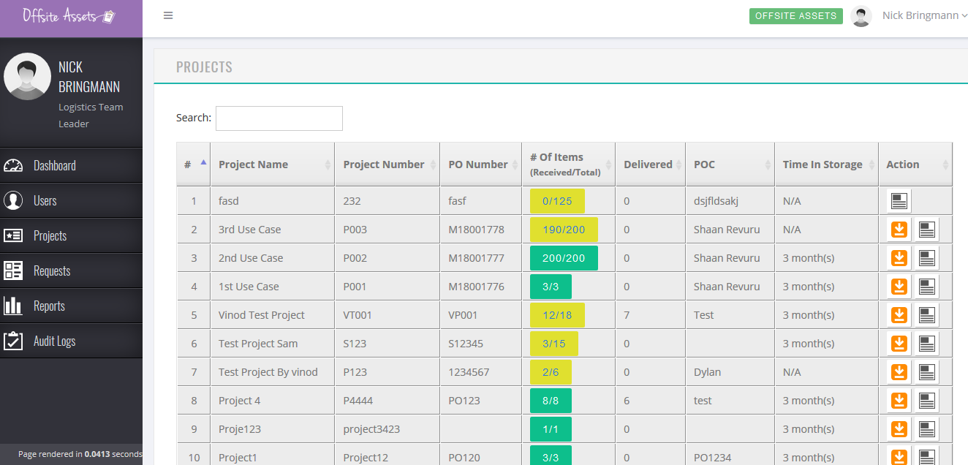
*What we have now*

Now that we have a PO from the Telecom team, we should get this important Cisco Module update revised and completed.

In Offsiteassets, we have the ability to add equipment with the green plus sign, we need the green plus sign to add projects. We had the ability initially, but the IT team changed it.

We also need the ability to add/edit item names/counts to that project.

Review JIRA Tickets: MEIM443 & MEIM 444 for details

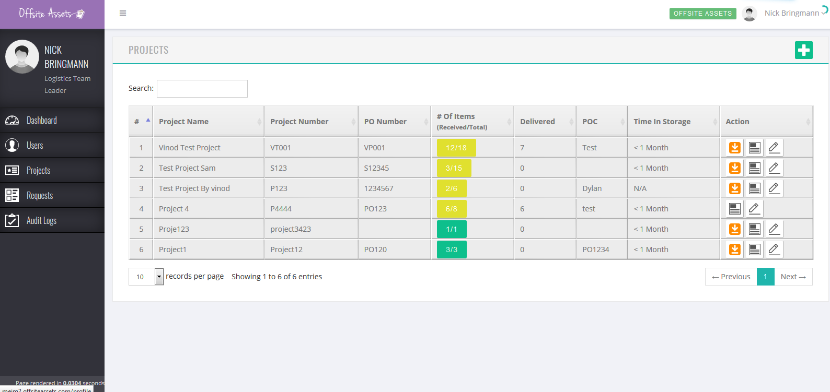
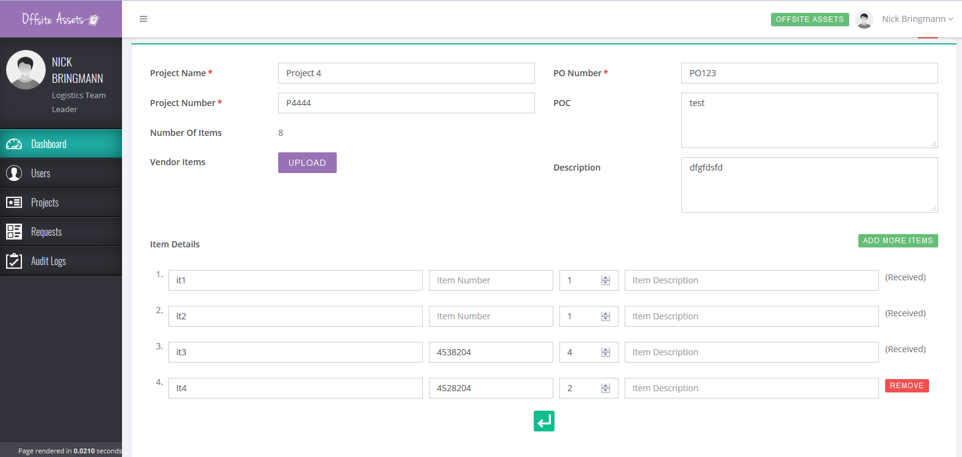
*What we had*

The photos above showcases how we used to be able to add/edit items to a project once a project is created. We cannot add/edit item names or counts if we cannot even make a project on the portal.

Above shows the green plus sign that we used to have on the project’s list page to add projects to this list.

The first photo in this document shows no addition symbol. Project 4 – P4444 was the project I made to test.

We should also have the ability to delete projects once deemed invalid as we do in the last photo showcasing removing items within that project.
Now we can only request items. We also had the green “Add more items” button.

